

**Learn BSL –** Would you like to learn Sign Language? Sarah Evagora will be offering a course in British Sign Language here at the Neurotherapy Centre starting in January. If you would like to join the course (which lasts 6 weeks) please contact Sarah on - sarah.bsltutor@gmail.com

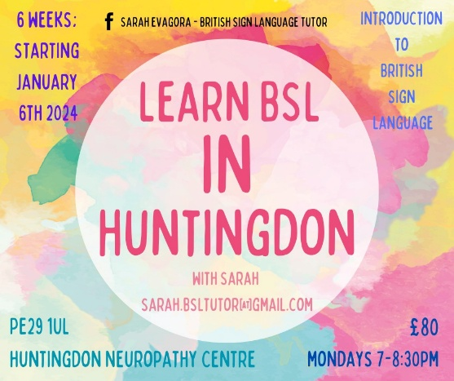

**Bingo –** Bingo is still going strong! We have our Christmas game (13th December) with an additional game for our loyal bingo players taking place after our normal game. There will also be some surprises for everyone, so make sure you don’t miss out!

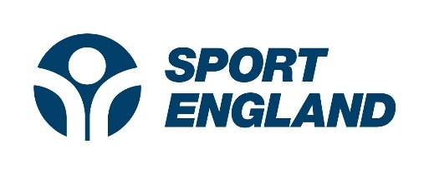**Successful Grant!** We are delighted to announce that Sport England have confirmed they will be granting us money to upgrade our gym equipment. This will give us vital funds to improve the safety, effectiveness and comfort for our members/classes.

We must give a big thank you to Sport England!

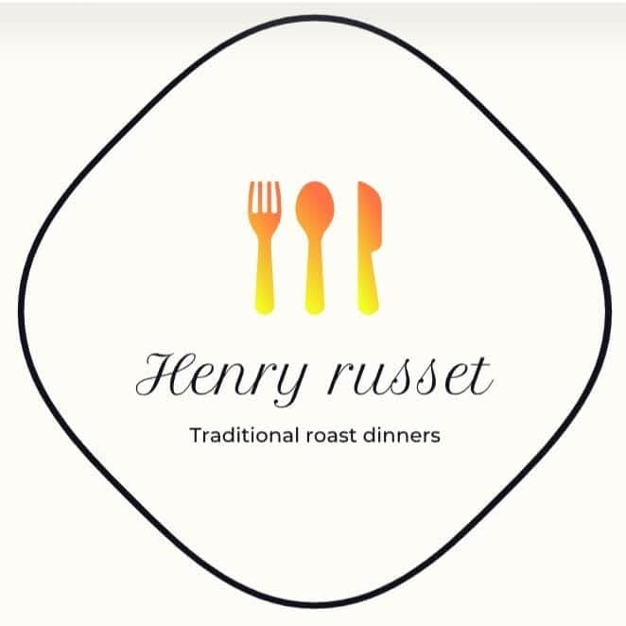**Sunday Roast -** We are delighted to announce that we are hosting Henry Russet here at the Huntingdon Neurotherapy Centre on Sundays (12pm-4pm).

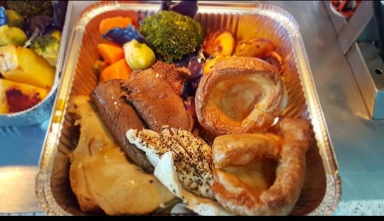Henry Russet offer stunning hearty Sunday Roasts.

Roast beef £12.

Roast chicken £10.

Nut roast

£13.

All served with Yorkshire puddings, stuffing, roast potatoes, carrots, broccoli, parsnips, red cabbage & gravy.   
  
limited spaces available already! So, if you are interested in ordering your Sunday roast, delivered directly to your door, then please contact the team directly on 07488365662 (preferably via whatsapp).  
Free delivery in Huntingdon

Hinchingbrooke £2, St Ives £3, Buckden £5, Alconbury and surrounding £5, Godmanchester £3.

**Huntingdon Neurotherapy Centre Membership** – Membership renewals will be due in January, so please bear in mind we will be collecting these when the time comes.

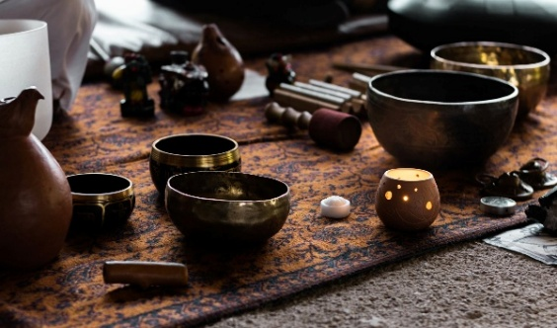**Sound Bath?**

Sound Baths consists of an instructor using different sound-producing tools to aid in deep relaxation and meditative states.

The concept of sound healing dates back millennia and uses Gongs, Singing Bowls, Drums, Rain Columns & Chimes. If this is something you are interested in, please get in contact.

Our next session will be Saturday the 7th of December at 10am. Do contact us to get booked in for this!

**Christmas Buffet -** This year's Christmas Buffet will be on Thursday the 19th of December, the buffet is for Members only! We only have a few spaces left for the buffet now. There will be vegetarian options available if this is something you are after.

**Christmas Craft Fair -** Make sure to join us on the 14th of December from 11 am onwards for our Christmas Edition. We have a large number of stalls this year, so much so that we can no longer take on anymore stall holders. Please do come on down to check out the amazing offerings and join in with the festivities

|  |
| --- |
| **SPECIAL OCCASIONS December Birthdays**   * David Copping 3rd * Shirley Ward 11th * Edyta Majcher 13th * Noel Baker 24th * Paul Fielding 30th * Roman Ramsay 30th |
| **UPCOMING EVENTS**   * Bingo - December 13th * Christmas Craft Fair - December 14th * Christmas Buffet - December19th |

**New** **Volunteers** We want you! especially when it comes to our Garden, if you or someone you know may be interested in lending a hand with the upkeep, please do get in touch. Our Garden is a vital outdoor space for our members to relax and unwind (weather permitting).