

**Happy New Year –** From everyone at the Huntingdon Neurotherapy Centre, we wish you a happy new year! Here’s to an amazing 2025!

Now the festivities have passed and everyone is getting back to normal, we hope to see you all back at the centre soon! We have lot’s on offer in the coming year and we are excited to see where things head.   
  
We are having our new lighting installed soon, with the aim of improving the energy efficiency of the building, saving costs, and improving lighting conditions both inside and out.  
  
We will also be using our new grant to update the gym and its contents, so we can offer you the best service possible in terms of our exercise classes and other activities in the gym.

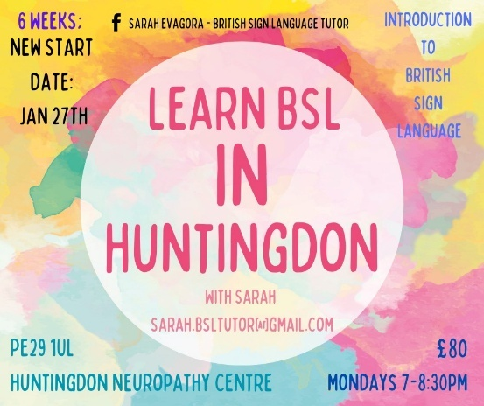**Learn BSL** – Would you like to learn a new skill in 2025?!Learn Sign Language with Sarah Evagora.

Sarah's course in BSL, hosted here at the Neurotherapy Centre, starts on January 27th, so you still have a chance to book in, if this amazing skill is something you would like to learn and you would like to join the course (which lasts 6 weeks) please contact Sarah on - sarah.bsltutor@gmail.com

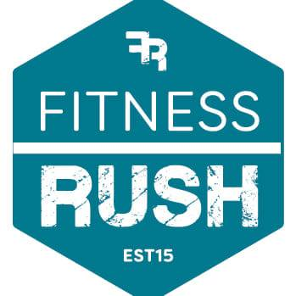**Fitness Rush -**

New Year New Fitness opportunity?! We are happy to announce that we will be hosting a FREE 6-week fitness program. Fitness Rush uses a mobile state-of-the-art modern fitness facility to carry out tailored fitness programs. These are for all levels of ability. The start date for this is Tuesday, the 4th of February, at 1 pm. Please come along to experience this amazing fitness program for yourself…

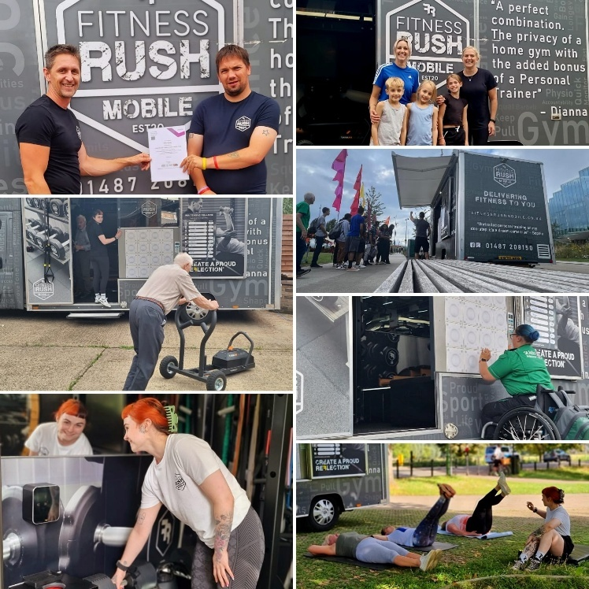

**Christmas Buffet 2024**

On the 19th of December, we held our annual Christmas Buffet. I feel it’s safe to say that everyone who attended had a wonderful time. The buffet was held for our centres members, who form our community and are the reason we operate.  
We aim to support anyone in need, we are very inclusive at the Neurotherapy Centre and everyone is welcome, you do not need to have a disability to be part of our community!  
  
We would like to thank Kyle and George for their hard work in preparing the buffet, and all of those who attended and made it a special event!  
  
We did not get a chance to take more photos of the event, as we were all having too much fun! but please see the lovely spread below.

**Huntingdon Neurotherapy Centre Membership** – Membership renewals will be due

in April.

**New** **Volunteers** We want you! especially when it comes to our Garden, if you or someone you know may be interested in lending a hand with the upkeep, please do get in touch. Our Garden is a vital outdoor space for our members to relax and unwind (weather permitting).

|  |
| --- |
| **SPECIAL OCCASIONS January Birthdays**  Tony Ixer 3rd  Daniel Garrett 6th  Pat Norman 6th  Michaela Broulikova 8th  Stephen Tomblin 10th  Gillian Lucas 14th  George Dutton 21st  Joseph Ighofose 27th |
| **UPCOMING EVENTS**   * Bingo - 31st January |