

**Sound Bath** Paula of Circles of Sound will be joining us again with 2 events!

Tuesday 18th Feb, Paula will be in one of our treatment rooms, from 10.30-13.30am, she will be bringing her Treatment Recliner for you to lay back & relax, while you enjoy a 1-1 Sound Treatment! This is only £20 & can be tailored to your needs, please book an appointment by contacting Paula on 07740 319169 or the email address below.

Paula’s Sound Bath is back again on Saturday 22nd February at 11am in the more standard group format.

Group Sound Bath is at the usual special price of just £10 for our centre!

A good opportunity to try something new, which will benefit your well-being.

Sound vibrations can aid better sleep, reduce blood pressure & calm stress, amongst many other benefits.

Just lay back & relax! Hire a comfy chair from Paula if needed.

If you have a yoga mat, bring that along, a blanket & cushion, and bring a bottle of water too.

To book & secure your place, tel. Paula 07740 319169 or email: [Circlesofsounduk@gmail.com](mailto:Circlesofsounduk@gmail.com)

**Quiz Night – March 29th** We are hosting another quiz night here at the centre on the 29th of March, so keep this date free! Tickets will be £5 each, a maximum of 6 players. Bring your own alcoholic beverages. Doors open at 6pm.

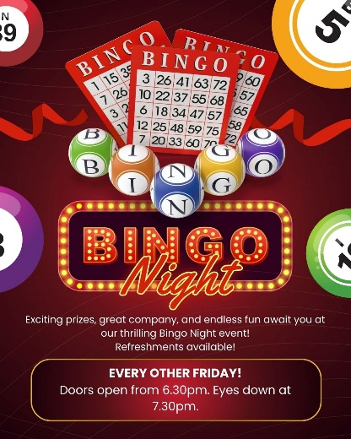**Bingo!** We have bingo this coming Friday the 14th, so please do come and join us. Bingo is continuing every other week, so after this Friday, the next is on the 28th, the more who attend the bigger the prizes!

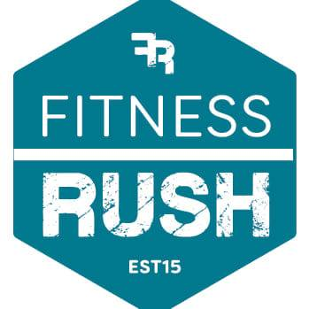**Fitness Rush -**Please do remember that Fitness Rush is still running their FREE fitness program! Fitness Rush uses a mobile state-of-the-art modern fitness facility to carry out tailored fitness programs. These are for all levels of ability. These run at 1 pm on Tuesdays.

**Learn BSL** – Would you like to learn a new skill in 2025?!Learn Sign Language with Sarah Evagora.

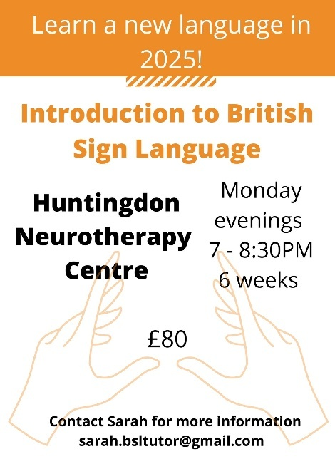

It's a taster, so it's suitable for complete beginners or those who want to refresh their knowledge

Sarah's course in BSL, hosted here at the Neurotherapy Centre, starts on February 24th, so you still have a chance to book in, if this amazing skill is something you would like to learn and you would like to join the course (which lasts 6 weeks) please contact Sarah on - sarah.bsltutor@gmail.com

**Huntingdon Neurotherapy Centre Membership** – Membership renewals will be due

in April. There will be two options, Full membership at £50 and a Social Membership at £25. Full membership gives reduced prices for oxygen therapy, whereas social membership does not.

|  |
| --- |
| **SPECIAL OCCASIONS February Birthdays**  Ruth Phelps 9th  Christine Belringer 11th  Angela Blake 12th  Mary Norman 17th  Angela Bezdeck 27th  Morag Wilkinson 28th |
| **UPCOMING EVENTS**   * Bingo 14th and 28th Doors open from 6.30pm eyes down at 7.30pm * 17th March 12pm - AGM, we encourage all to attend |

**New** **Volunteers** We want you! especially when it comes to our Garden and our Hyperbaric Oxygen Chamber.

With spring around the corner and an uptake in oxygen therapy users, we would love for volunteers to come forward for either of these vital duties. So, if you or someone you know may be interested in lending a hand, please do get in touch. Our Garden is a vital outdoor space for our members to relax and unwind (weather permitting) and our Hyperbaric Oxygen Chamber is the top treatment therapy we have on offer.