**Annual General Meeting –** Just a reminder that we have our annual general meeting on the 17th of March at 12pm . Please do attend if you can, this is central to the running of the centre.  
  
**HBOT – Introductory offer!** We are pleased to announce that as of the beginning of this month we now have a £10 introductory offer for new users of the Hyperbaric Oxygen Chamber. This offer applies only to new users and their first session.   
We must make people aware that we are currently fully booked for our 16.5ft sessions, we are currently attempting to run additional 16.5ft sessions to accommodate the increase in demand. If you would like to be a volunteer chamber operator to help us accommodate this increase in demand, please do contact us!

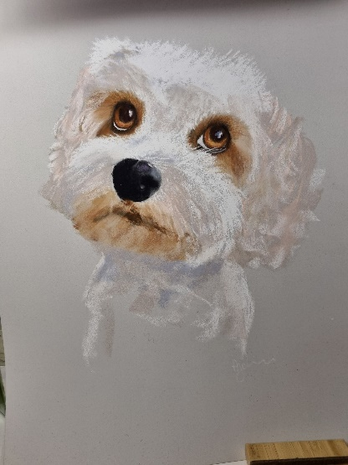**Colour Coffee And Chat –** We would like to give a big shout out to Debs Stevens and Zoe Tarling who now run the new ‘Colour, Coffee and Chat’ group. We had lots of new people attend the last session (4th of March 10am-2pm), with lots of lovely watercolours produced by the attendees. Lot’s of fun had by all! The next session will be on the 18th of March 10am- 2pm, so be sure to drop in! (picture by Hazel Johnson)

**Quiz Night – March 29th** We are hosting another quiz night here at the centre on the 29th of March, so keep this date free! Tickets will be £5 each, a maximum of 6 players. Bring your own alcoholic beverages. Doors open at 6pm. Our last event was great fun for all involved!

**Bingo!** We have Bingo this coming Friday the 14th, so please do come and join us. Bingo is continuing every other week, so after Friday, the next is on the 28th, the more who attend the bigger the prizes!

**Raffle –** We are still having our monthly raffle, we have multiple prizes up for grabs, the draw will take place on the27th March Tickets are £2. Drop in the centre for a cup of coffee or a snack, and grab yourself a ticket!

**Huntingdon Timber Supplies –** Have been kind enough to donate the timber posts needed to carry out a raised bed project in the communal garden. A big thank you must go to Daniel Marsh (Branch Sales Manager). If you have any projects coming up that require timber, please do give them a call on 01480 455588

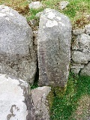**Qi Gong and Tai Chi** Classes with Thelma take place in the gym on Thursdays at 12.15 and last an hour. Along with these we practice short, guided meditations for intention of movement through expansion and release of the musculoskeletal structure. The movements are based on the Yin and Yang principles, balance is an essential part of Tai Chi. Like nature, we are happier and healthier when in harmony.

Shaolin warriors and monks use the slow movements as a form of ***Shadowboxing***, giving them a better understanding of movement without adding stress to the body.

The sessions are quietly relaxing which allows you to have some time for yourself to

calm the mind and allow the body to recharge and promote an overall sense of wellbeing.

**New** **Volunteers** We want you! especially when it comes to our Garden and our Hyperbaric Oxygen Chamber.

|  |
| --- |
| **SPECIAL OCCASIONS March Birthdays**  Samantha Hollis 14th  Gavin Whittington 15th  Hazel Thomson 16th  Julie Westra 19th  Sally-Anne Carline 20th  Clive (Fred) Beamish 23rd  Sue Higgins 31st |
| **UPCOMING EVENTS Annual General**  March 29th – Quiz night! We are hoping to make this another great night, so please do come and join in the fun!  Bingo – 14th and 28th  Annual General Meeting - 17th of March 12pm |

With uptake in oxygen therapy users, we would love for volunteers to come forward for either of these vital duties. So, if you or someone you know may be interested in lending a hand, please do get in touch. Our Garden is a vital outdoor space for our members to relax and unwind (weather permitting) and our Hyperbaric Oxygen Chamber is the top treatment therapy we have on offer.

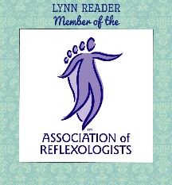**Reflexology –** Offering Reflexology since 2015 and working intuitively with her clients, Lynn offers a relaxing and therapeutic treatment session. Offering treatment in one of our treatment rooms, Lynn permanently rents the room with us, due to her ongoing success and demand for the service. Reflexology is in essence massaging of the hands and feet, which can help ease stress and tension. It can also help support you through illness, aid with sleep and improve emotional wellbeing. If you would like to learn more about reflexology or to have a treatment with Lynn, please contact her on 07985 407129.

**Huntingdon Neurotherapy Centre Membership** – Membership renewals will be due

in April. There will be two options, Full membership and a Social Membership, we will be keeping fees as low as we can. Full membership gives reduced prices for oxygen therapy, whereas social membership does not.