**Successful Grants and Funding -**As many of you will know by now, we have had successful grants from The National lottery, Green Business, Sports England and Waitrose/John Lewis!  
  
We have been able to utilise the National Lottery fund to help renovate and rejuvinate our beautiful communal garden, with the addition of a greenhouse, raised beds, new benches and much more. Do pop in to see our progress with this over the coming months, we are excited to create more opportunities for the community to use our communal Garden.

We are always looking for volunteers to assist with our ongoing Garden renovations, so if this is something you feel you would be able to help with, please get in contact.  
  
The Green Business grant has enabled updated lighting throughout the centre, including energy saving features such as motion sensors on certain lights, wiith the aim of saving us money on our electricity bill and saving the environment by preventing waste.

Sports England have enabled us to aquire lots of new Gym equipment, which we will be detailing more of in the future. We will be holding more exercise classes (keep your eyes out for these), enabling us to cater to a wider audience.

The funds from Waitrose/John Lewis will contribute towards the running of the centre and is, again, much appreciated!  
  
We would like to thank everyone who has supported us via grants and funding; without you, we would not exist.

**Dementia Community Group –** Sarah and Anna had a wonderful visit to the dementia community group, held at the Huntingdon Library. They discussed the Café, Garden, Gym and everything else we have on offer.

If you know of any other groups out there that would like a visit from us to explain what we have on offer at the centre, please do reach out to us.

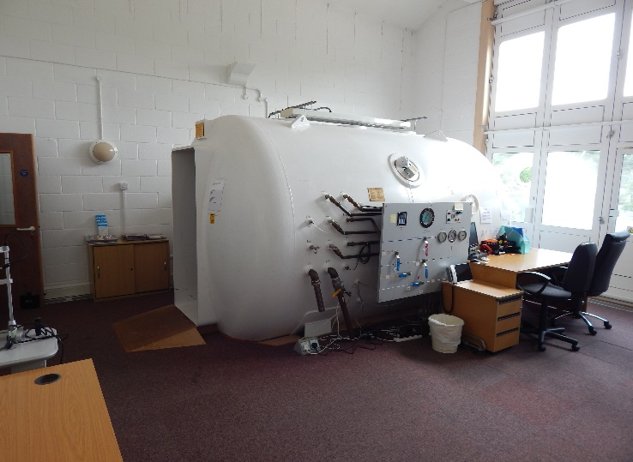**HBOT – Introductory offer!**

We are pleased to announce that we are still running the £10 introductory offer for new users of the Hyperbaric Oxygen Chamber *This offer applies only to new users and their first session only*   
We have created a new 16.5ft session to meet increased demand, this is on Monday’s at 11.45am. If you would like to be a volunteer chamber operator to help us accommodate this increase in demand, please do contact us!

**Ben Obese-Jecty -** will be visiting the centre on Monday 14th April from 9am till 10.30am, he will be available for questions during this time.

**Chamber Chairs -** We are currently in the process of replacing all the chairs in our hyperbaric oxygen chamber. These chairs are very worn out, and we are hoping to maximise comfort and conditions for our chamber users.

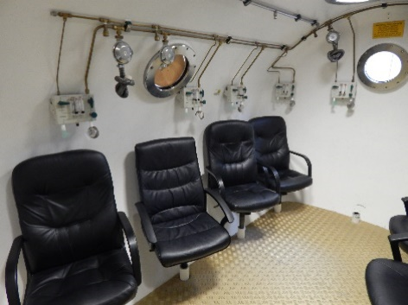

**If you would like to sponsor a chair**, you can sponsor a whole chair for £160, half a chair for £80, or quarter of a chair for £40, your name will be added to a plaque in the chamber room (no mention of your donation amount).

**Qi Gong and Tai Chi** Don’t forget Thelma’s **Introductory Class at 10am on Monday 12th of May** (Cost of this lesson is £5) with the aim of this continuing on following Mondays.. Thelma’s lessons also take place in the gym on Thursday’s at 12.15 and last an hour. Along with these, Thelma also practices short, guided meditations for intention of movement through expansion and release of the musculoskeletal structure. The movements are based on the Yin and Yang principles, balance is an essential part of Tai Chi.

**Huntingdon Neurotherapy Centre Membership** – Membership renewals are now due. There will be two options, Full membership (£50) and a Social Membership (£25) . Full membership gives reduced prices for oxygen therapy, whereas social membership does not.

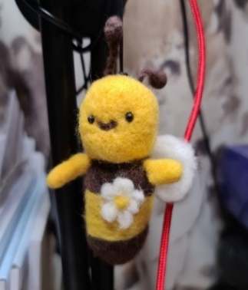**Create And Share –** Debs Stevens and Zoe Tarling, who now run the new ‘Colour, Coffee and Chat’, also run a ‘Create and Share’ Event. Bring along whatever craft you may be working on. Everyone is welcome! Have some crafting materials that you would like to swap? Maybe you have some yarn that you could do with letting go of? Bring it with you as we 'Create and Share' together! We have had lots of new people join in these groups, so please do come along to the next one on 22nd April from 10am till 1pm.

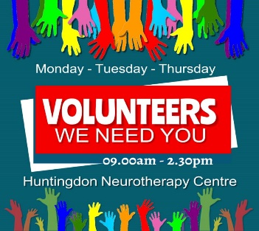**New** **Volunteers** We want you! Especially when it comes to our Garden and our Hyperbaric Oxygen Chamber. Hello to our new volunteers Kat and Kat, they will be helping in our Café and with ongoing Garden projects.

|  |
| --- |
| **SPECIAL OCCASIONS**  **April Birthdays**  Ellen Woodbridge 1st April Kay Rice 12th April  Julie Marie Green 12th April Wendy Barke 15th April Brenda Northrop 23rd April Katie Soper 29th April |
| **UPCOMING EVENTS**  **April 2025**  Ben Obese-Jecty visit – 14th April 9am Bingo 11th and 25th of April Introductory Qi Gong and Tai Chi class – 12th May 10am |