

**Ben Obese-Jecty visit –** Our local MP, made a visit some weeks ago now, he was impressed with what we had on offer and the fact that we are self

funded.

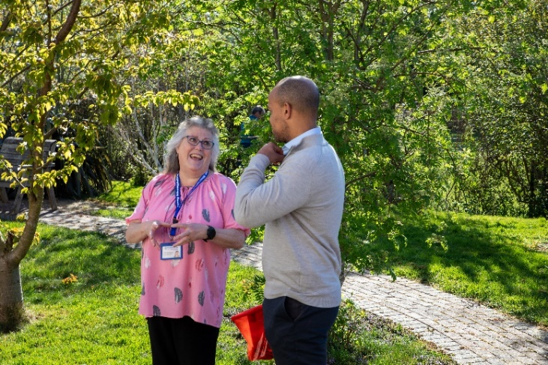

He loved the fact we are aiming to become AFC affiliated and helping ex-service members with their rehabilitation.

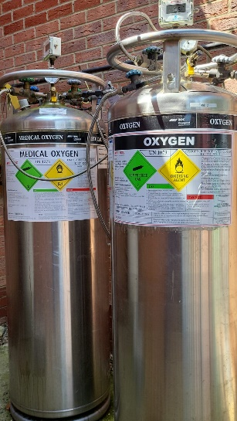As a fellow scuba diver, Ben understood the concept of our Oxygen Chamber, but did not realise we are open to everyone. We thank Ben for taking time out of his busy schedule.  
  
**Hyperbaric Oxygen Chamber Supply Tank**Due to increased demand, we desperately need a new oxygen supply tank. We need to raise £7500 for this! Currently, we have two medical grade tanks and need a third in order to meet the new demand.  
  
We will therefore be doing the same ‘sponsor a tank’ like we did with our new chamber chairs. We will, again, put anyone who helps to sponsor the new tank on a plaque. If you are able and willing to do this, please contact us!

**Working BBQ – July 19th**This upcoming working BBQ is a major event for us, if you are able to use basic tools such as a trowel, fork, screwdriver etc, please do come along and give us a hand, whilst having some fun at the same time!

Please pre-order your food ahead of time, we have either homemade burgers or sausage rolls, with sides – coleslaw, potato salad and a rice dish.

**HBOT – Introductory offer!**

We can confirm we are still running the £10 introductory offer for HBOT (first session only). Due to increased demand we are having more frequent deliveries of the pure oxygen the chamber requires.

We have created a new 16.5ft session to meet increased demand, this is on Mondays at 11.30am.   
  
If you could choose, would you prefer evening or weekend oxygen sessions? Please give us feedback to gauge interest.

**Recent Benefactors** We have had several recent benefactors. We would like to say a big thank you to Bruce at Brookview Glaziers, who, along with his team, installed the large new mirror in our gym.

We would also like to say a big Thank You to Mike Dyer from UK Amenity, who also

helped us by treating the weeds in our block paving/Garden.

**Chamber Chairs -** The Huntingdon Neurotherapy Centre members have all clubbed together and sponsored the new chairs for the Hyperbaric Oxygen Chamber.

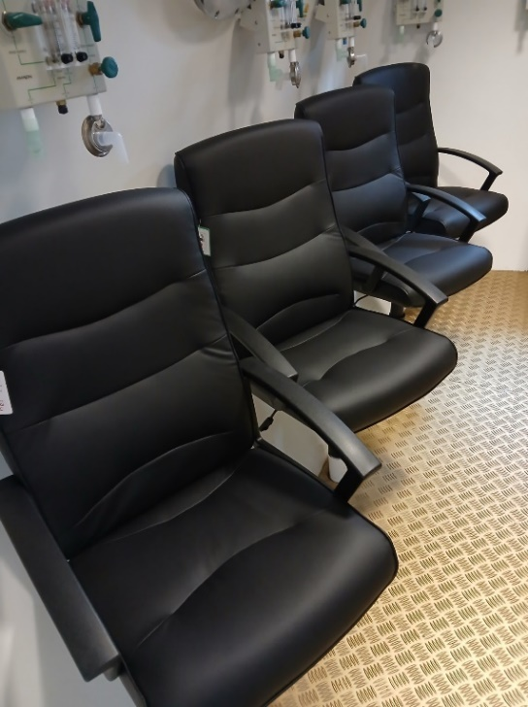A massive thank you to everyone who has helped make this happen. Your names will all now go down on the plaque forevermore! Thank you, thank you!

These chairs were provided and installed by Alexander Green Office Interiors, based in Royston. We hope that this provides an added layer of comfort.

**New** **Volunteers** We Want You! Especially when it comes to our Garden and our Hyperbaric Oxygen Chamber. Below is a picture of Dave, one of our long-term volunteers who helps in the Garden, pictured with Ben when he visited the centre.

Would you be able to help us in the Café, the Garden, our oxygen chamber or just around the centre in general? We have tasks for all levels of ability/time availability. If you can use a garden fork, a shovel, hammer, screwdriver etc (you get the idea!) then you can help us!

|  |
| --- |
| **SPECIAL OCCASIONS**  June Birthdays: Andrea Percy 3rd  Anita Nitsche 6th  Catrina Duffy 25th  Deb Stevens 8th  Jane Coffin 13th John Bushell 3rd John McNulty 13th Laura De Stefano 18th  Linda Lane 27th |
| **UPCOMING EVENTS**  **June 2025 and beyond**  Bingo every other Friday as usual – 27th June 19th July – working BBQ |