

**__________________**

**Garden Progress - We need you this weekend!**As we mentioned in the last newsletter, we are having a working BBQ this Saturday the 19th!

Kat and the two Daves have made wonderful progress in the Garden (especially on the raised beds pictured below) and we hope to continue this at the working BBQ.

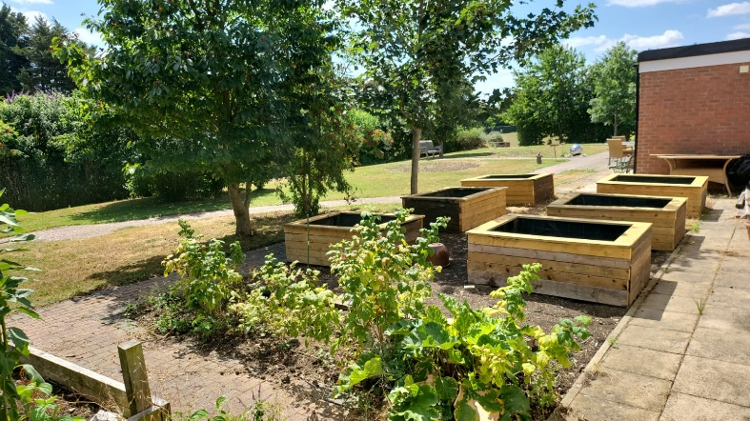  
We aim to rotovate the area around the raised beds, so that we can remove some of the soil and put membrane down, followed by sand and then paving stones. These beds are designed to allow full wheelchair access.

We have six new raised beds, two new water butts, sixty paving slabs on the way to create hard standing around the raised beds, a green house and a potting shed (which we hope to put up during the working BBQ).

**__________________________________________**

Our aim is for the garden to provide fresh produce for our café and any excess for the volunteers and local community, whilst also providing a theraputic space for anyone wanting to use it.

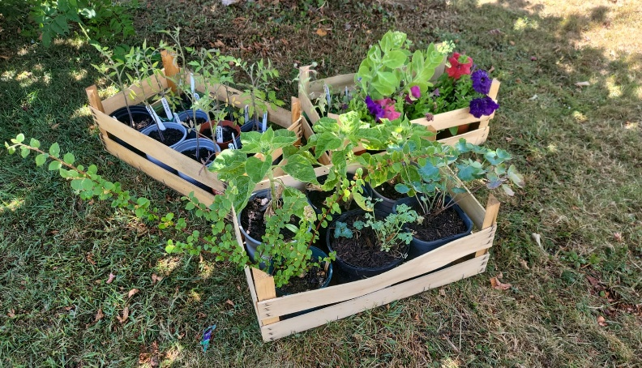Below are some of the flowers/plants which have been donated to us by “wild about Huntingdon” (Thank you!) who are a group dedicated to improving our town for nature, the environment and ourselves. We hope to get these planted this weekend.   
  
We also have the same goals in mind, and hope to make this wonderful space more enticing to polinators and other insects. Below you can see our pond, which we hope to clean during the working BBQ, to make it more welcoming to the local wildlife and for us to enjoy asthetically. We are so very blessed to have this amazing outdoor space.

**Working BBQ – July 19th**This upcoming working BBQ is a major event for us, if you are able to use basic tools such as a trowel, fork, screwdriver etc, please do come along and give us a hand, whilst having some fun at the same time!

Please pre-order your food ahead of time, we have either homemade burgers or sausage rolls, with sides – coleslaw, potato salad and a rice dish.

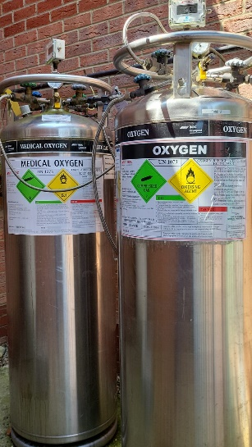**Hyperbaric Oxygen Chamber Supply Tank**Due to increased demand, we desperately need a new oxygen supply tank. We need to raise £7500 for this! Currently, we have two medical grade tanks and need a third in order to meet the new demand.  
  
We will therefore be doing the same ‘sponsor a tank’ like we did with our new chamber chairs. We will, again, put anyone who helps to sponsor the new tank on a plaque. If you are able and willing to do this, please contact us!

**New** **Volunteers** We Want You! Especially when it comes to our Garden and our Hyperbaric Oxygen Chamber. Below is a picture of Dave, one of our long-term volunteers who helps in the Garden, pictured with Ben when he visited the centre.

Would you be able to help us in the Café, the Garden, our oxygen chamber or just around the centre in general? We have tasks for all levels of ability/time availability. If you can use a garden fork, a shovel, hammer, screwdriver etc. (you get the idea!) then you can help us!

|  |
| --- |
| **SPECIAL OCCASIONS**  July Birthdays: Tim Barke 10th Lynne Davies 12th Charlotte Hart 12th Kelly Palmer 13th  Graham Wass 15th Sarah Greenstock 17th Sheila Lloyd 19th  Mark Van-Der-Gaag 27th |
| **UPCOMING EVENTS**  **July 2025 and beyond**  19th July – working BBQ Bingo 25th July and 8th of August |