

**__________________**

**New – Exercise (and singing) classes!**

Our very own Sarah will now be hosting several new exercise classes, along with singing lessons.  
Below is a copy of Sarah’s full timetable, which details both the old and new classes (Starting the 8th of Sept)

|  |
| --- |
| **Monday** |
| Personal sessions - 9.00 -9.25 or 9.30 to 9.55  £18 per 25 minutes |
| Floor-based fitness Pilates - 10.00 - 10.55 - £6 |
| Balance blitz - 11.00 - 11.25 - £3 |
| Seated exercise - 11.30 - 12.25 - £6 |
| **Tuesday** |
| Personal sessions - 9.00 -9.25 - £18 per 25 minutes |
| Singing - 1.00 - 1.45 - £5 |
| Parkinsons workout - 1.45 - 2.45 - £5 |
| **Thursday** |
| Personal sessions - 9.00 -9.25 or 9.30 to 9.55  £18 per 25 minutes |
| Standing exercise - 10.00 - 10.55 - £6 |
| Seated exercise - 11.00 - 11.55 - £6 |
| Parkinsons workout - 1.30 - 2.30 - £5 |

We encourage both old and new users of the centre to explore whether there are any new sessions they would like to explore, please contact sarah on

[Thrivewithsarahg@gmail.com](mailto:Thrivewithsarahg@gmail.com) Mobile - 07712658001

We welcome all abilities and age groups, from seated exercise classes to standing exercises and balanze blitz, which uses balance boards and different techniques focusing on posture, centering and alignment to help improve balance.

The singing lessons are fun and uplifting sessions, but are also so much more than singing; offering vocal exercises and breathing techniques along with relaxation, all elements that not only help with singing but speech too. So, whether you want to work on singing and vocal techniques, harmonies, breath control, relaxation and more, or just have a good sing along to your favorite styles and genres, then this is the session for you.

**__________________________________________**

**Quiz Night – October 11th** We are hosting another quiz night here at the centre on the 11th of October, so keep this date free! Tickets will be £5 each, a maximum of 6 players. Bring your own alcoholic beverages. Doors open at 6pm – 6.30pm start. Our last event was great fun for all involved!

**Working BBQ – August 23rd**The working BBQ was a success, with us working on the raised beds, installing the new green house and finishing off the potting shed/paved area around the potting shed.

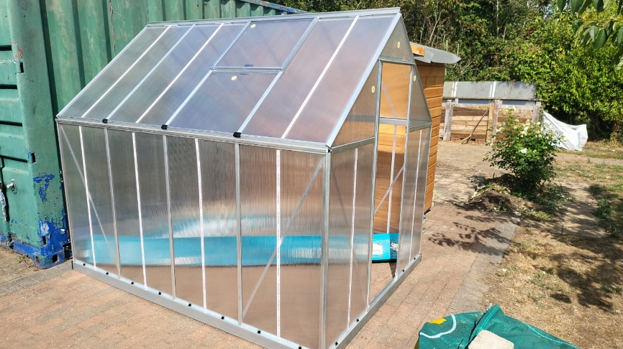

We are really pleased with the results so far and with just a little more work, we will be accessaible to all, including wheel chair users. The raised beds have been specifically designed with this in mind.

|  |
| --- |
| **SPECIAL OCCASIONS**  **August Birthdays** George Whittington 03/08 Jennifer Tomblin 18/08 Dean Hinton 21/08  **September Birthdays** Fran Charman 14/09 Brenda Copping 15/09 Frances Hinton 18/09 Alex Wilson 27/09 Clive Micklefield 28/09 Peter Robinson 30/09 |
| **UPCOMING EVENTS**  **August / September 2025 and beyond**  Bingo September 12th and the 26th October the 11th – Quiz Night |

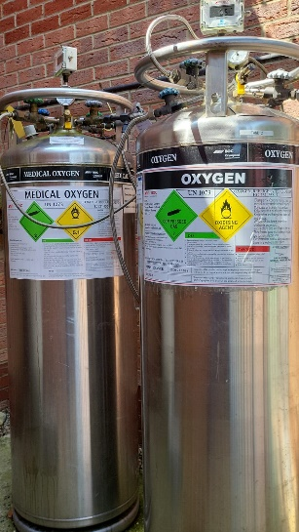**Hyperbaric Oxygen Chamber Supply Tank**Due to increased demand, we have finally installed a new oxygen supply tank, we now have 3!. We need to raise £7500 to cover the costs of the installation for this. Now that we have this extra supply tank, we are able to consider additional sessions/times.  
  
We are essentially doing ‘sponsor a tank’ as we did with our new chamber chairs, to try and cover this massive expense. We will, again, put anyone who helps to sponsor the new tank on a plaque. If you are able and willing to do this, please contact us!

**New** **Volunteers** We Want You! Especially when it comes to our Garden and our Hyperbaric Oxygen Chamber. We also need help in our kitchen, so if you are culinarily gifted, please get in touch. Below is a picture of Dave, one of our long-term volunteers who helps in the Garden, pictured with Ben when he visited the centre.

Would you be able to help us in the Café, the Garden, our oxygen chamber or just around the centre in general? We have tasks for all levels of ability/time availability. If you can use a garden fork, a shovel, hammer, screwdriver etc. (you get the idea!) then you can help us!

**Qi Gong and Tai Chi** Don’t forget Thelma’s lessons also take place in the gym on Thursday’s at 12.15 and last an hour. Along with these, Thelma also practices short, guided meditations for intention of movement through expansion and release of the musculoskeletal structure. The movements are based on the Yin and Yang principles, balance is an essential part of Tai Chi.