

**__________________**

**New – Exercise (and singing) classes!**

Sarah is hosting several new exercise classes, along with singing lessons. Here are just a few of her new classes:

We encourage both old and new users of the centre to explore whether there are any new sessions they would like to explore, please contact sarah on

[Thrivewithsarahg@gmail.com](mailto:Thrivewithsarahg@gmail.com) Mobile – 07712658001  
  
Sarahs Singing lessons run on Tuesdays from 1pm – 1.45pm. These sessions are fun and uplifting, providing vocal exercises and breathing techniques along with relaxation, which help with both singing and speech.  
Join us for a good sing along to many of your favourite tunes.  
  
**Halloween Tea Party –** We are hosting a halloween afternoon tea party on the 30th of October from 3-5pm. The mayoress Cllr Audrey McAdam (who is one of our benefactors) will be in attendance. Bayleaf care homes are generously providing the food for this event. Tickets are £5 per person.

**__________________________________________**

**Quiz Night – October 25th** We are hosting another quiz night here at the centre on the 25th of October, so keep this date free! Tickets will be £5 each, a maximum of 6 players per group. Bring your own alcoholic beverages. Doors open at 6pm – 6.30pm start. Our last event was great fun for all involved!

**Christmas Buffet –** Amazingly, it is nearly that time of year again! Our Christmas buffet, which proved to be a real success last year, will be on the 16th of December, starting at 12.00pm. Tickets will be £15.00 per person, please book your space as soon as possible, as tickets are selling fast!  
  
Picture below from last years Christmas Buffet!

**Beautiful By Karen –** We would all like to say a massive good luck to Karen, as she will be leaving us on the 20th of October. Karen thank you for eveything you have done for the centre and good luck with your future endevours.

**Colour Coffee And Chat** now runs on Tuesdays 10am-12.30, with the next one on the 14th of October.

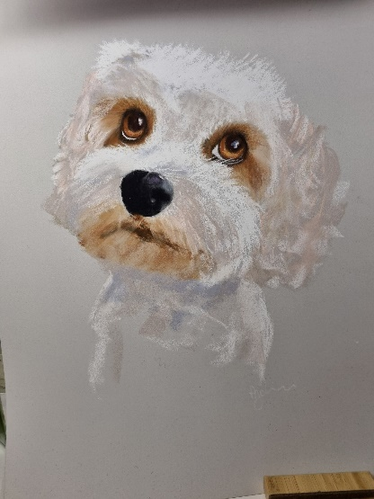

Here is one of the beautiful watercolours produced by one of the attendees. If you would like to get back in touch with your creative side, please come along and join in.

**Create And Share** Is also now on Thursdays 10am-12.30 with the next on the 16th of October.

these run fortnightly and all levels of ability in crafts and artwork are welcome.

**New** **Volunteers** We Want You! Especially when it comes to our Garden and our Hyperbaric Oxygen Chamber. We also need help in our kitchen, so if you are culinarily gifted, please get in touch. Below is a picture of Dave, one of our long-term volunteers who helps in the Garden, pictured with Ben when he visited the centre.

Would you be able to help us in the Café, the Garden, our oxygen chamber or just around the centre in general? We have tasks for all levels of ability/time availability. If you can use a garden fork, a shovel, hammer, screwdriver etc. (you get the idea!) then you can help us!

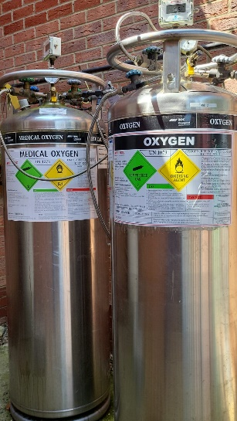**Hyperbaric Oxygen Chamber Supply Tank**Due to increased demand, we have finally installed a new oxygen supply tank, we now have 3!. We need to raise £7500 to cover the costs of the installation for this. Now that we have this extra supply tank, we are able to consider additional sessions/times.

Please ask about the ‘sponsor a tank’ scheme, as we are raising money to help cover the cost of this installation.

|  |
| --- |
| **SPECIAL OCCASIONS  October Birthdays** Adrian Meadows – 03/10 Samad Mishima – 07/10 Anna Dutton – 08/10 Lisa Jane Porter - 15/10 Melinda Rose – 15/10 Norman Knapper – 18/10 Steven Cockeram – 25/10 Thelma Segal – 29/10 |
| **UPCOMING EVENTS**  **October**  10th and 31st – Bingo  14th and 28th – Colour, Coffee and Chat 16th and 30th – Create and Share 25th – Quiz Night  30th – Afternoon tea  **December**  16th December - Christmas Buffet |